COPPER COUNTRY ALLIANCE

HC 60 Box 306T

Copper Center , Alaska 99573 Phone (907) 822-3644

cca@coppervalley ak.net

Ci *501.* (c) (3) *V\,011\,--pYofit COY"j)DYCihova*

"Vrotect *tVle* n/4Y l vl,d \-V lci ll\}.),b,,tYCfl *evvVi.Y oVL-w..ev"-,t of* the C,7P-per Bci.s[J/\,/wn:iv--gell fv\D{,{11\,t/:lLJ/\,.s *reg Lovt."*

July 2, 2021

Copper Country Alliance (CCA) is a volunteer grassroots 50l(c)(3) organization that addresses conservation issues in the Copper Basin. The majority of our members are Copper Basin residents. CCA appreciates the opportunity to provide comment on the Draft 2021 East Alaska RMP Amendment EA. The comments below are submitted by Danny Rosenkrans CCA board member, on behalf of the Copper Country Alliance.

Comment#!

*"2.4 Alternatives Considered but not Analyzed in Detail An alternative suggested by public scoping comments asked the ELM to consider other lands for exchange instead of the two proposed sections under Alternative 2. The ELM manages relatively few public land5 in the Chugach Region. The Dingell Act requires the ELM to identify lands it can make available for land exchange with CAC that are accessible and economically viable. The ELM was unable to identify any lands under its management in the Chugach Region Land Exchange Study which meet these requirements of the Dingell Act to analyze other than the two proposed sections under Alternative 2"*

The EA should describe what deems these two sections as economically viable and if so, that economic development should be described, and the impacts assessed. There does not appear to be an adequate description of

what might happen on these lands related to economic development. It appears as if a road to connect the previously conveyed lands to the east with the Richardson Hwy and/or infrastructure for backcountry recreation, both winter and summer seasons are possible developments. Developing a road and constructing infrastructure would both significantly alter the landscape and viewshed eastward towards the Tasnuna Valley, which is pristine, snmning, and viewed by all tourists driving over Thompson Pass during the summer.

Comment#2

If the economic issue is an access road to Chugach Lands to the East, then perhaps an alternative in the EA should be developed for providing a road easement only.

Comment#3

Clarify what NEPA would be undertaken if the subject lands (2 sections) were to become part of a future land exchange . It is unclear how one can assess the benefits of such an action until and unless one knows which lands the BLM would exchange these 2 sections for, and if that decision is warranted or based upon "equal area". Would it be lands within the Eastern Alaska Area Plan, the Tiekel Block or elsewhere? Perhaps the potential lands for a future Exchange should be identified in consultation with Chugach Corp and provide for like-kind recreational use and scenic quality.

Sincerely,

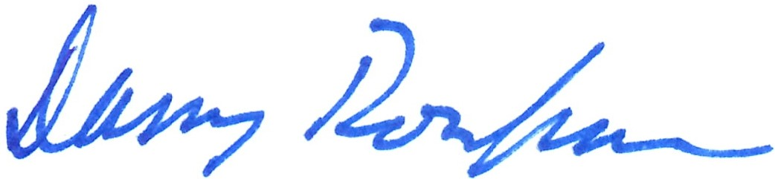

Danny Rosenkrans CCA board member